**POWER BI PROJECT**



**US Healthcare analysis**



**Madhav R. Yawale**

**OBJECTIVE**

The project's primary aim is to utilize Power BI to conduct an exhaustive analysis of healthcare industry data spanning a year, with a particular focus on identifying key trends and insights essential for informing policy decisions within the US government. It involves creating comprehensive dashboards meticulously designed to offer a multifaceted view of the healthcare landscape. These dashboards include an Executive Summary, distilling essential Key Performance Indicators (KPIs) and overarching trends, providing government officials with a strategic overview of the healthcare industry's performance and evolution.

Moreover, the project entails developing separate, tailored views within the dashboards to cater to the diverse needs and interests of different stakeholders within the healthcare ecosystem, such as Hospitals, Payers, Providers, and Patients. By providing specialized dashboards for these distinct stakeholder groups, the project ensures that the insights derived from the data analysis are relevant, actionable, and directly applicable to the specific challenges and opportunities faced by each constituency.

A core objective of the project is to shed light on the profound impact of the COVID-19 pandemic on the healthcare industry. Through rigorous data analysis and visualization, the project aims to elucidate the various ways in which the pandemic has influenced healthcare delivery, utilization patterns, financial dynamics, and patient outcomes. By offering a nuanced understanding of these dynamics, the project equips government officials with the insights necessary to make informed decisions and formulate effective strategies for addressing the ongoing challenges posed by the pandemic.

**DATA DICTIONARY**

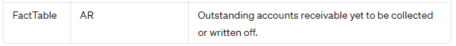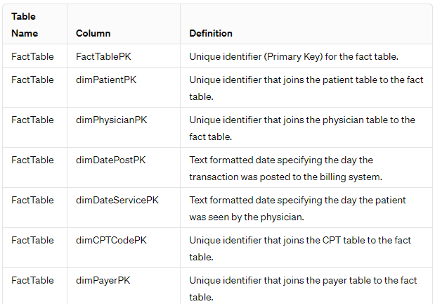**FACT TABLE:**

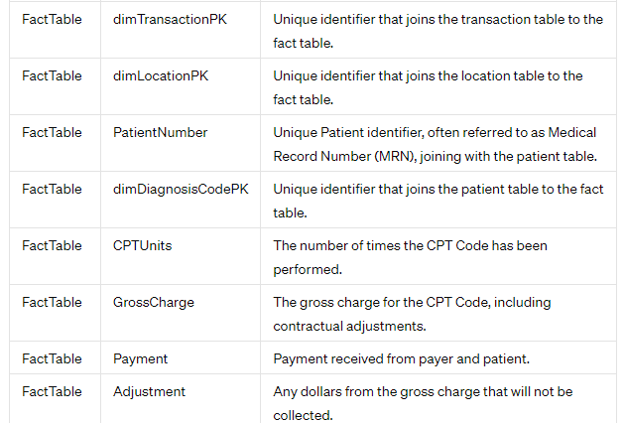

**Patient Table:**

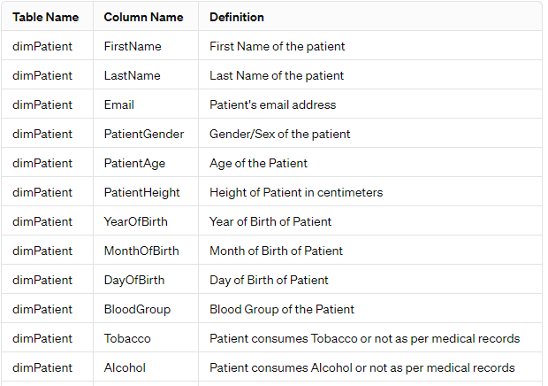

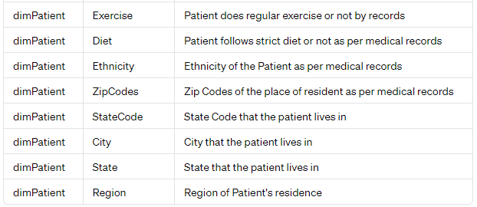

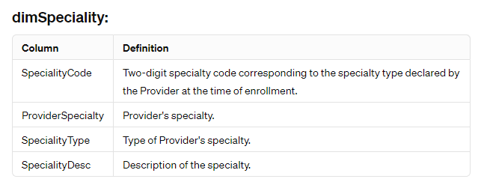

**Transaction Table:**

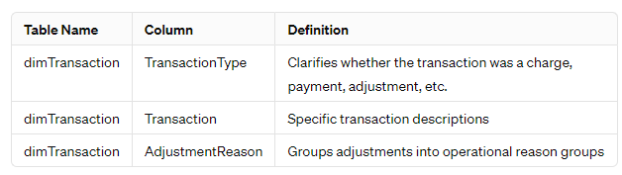

**Physician Table:**

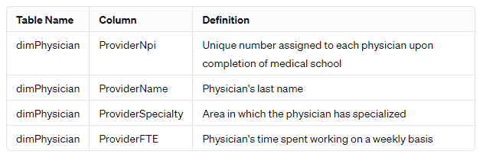

**Payer Table:**

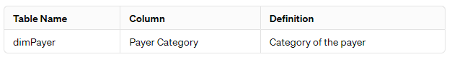

**Diagnosis code Table:**

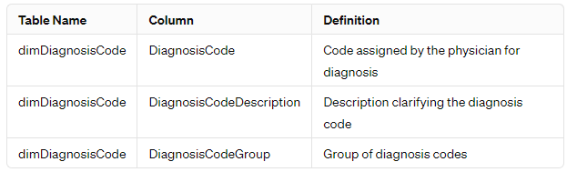

**CPT code Table:**

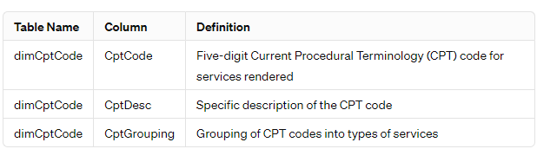

**Date Table:**

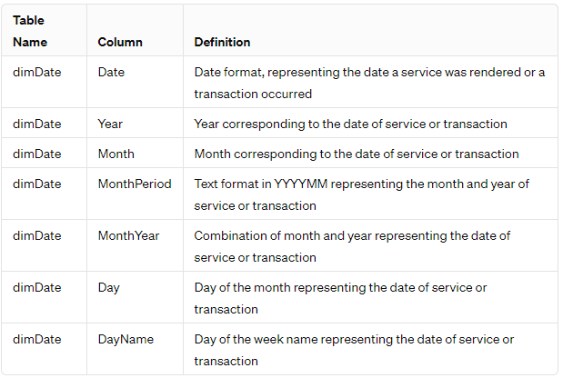

**Hospital Table:**

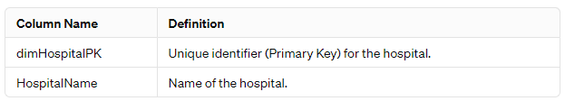

**KEY FEATURE**

**1. Thorough Data Analysis:** Conducts a comprehensive examination of healthcare industry data, providing detailed insights into patient demographics, expenses, and treatment trends.

**2. Interactive Data Visualization:** Utilizes a diverse range of charts and graphs, such as bar charts, pie charts, line charts, and area charts, to effectively present data and enhance comprehension.

**3. Dynamic Data Exploration:** Empowers users to dynamically explore data through customizable filters based on parameters like region, hospital, payer, provider, and patient demographics.

**4. Hospital Performance Analysis:** Delves into various facets of hospital performance, including accounts receivable, procedure volumes, and financial ratios. Identifies hospitals with significant accounts receivable and insurance payment ratios to assist in financial management strategies and resource allocation.

**5. Patient Demographics and Treatment Patterns Analysis:** Provides insights into patient demographics, behaviors, and treatment patterns. Examines trends in patient admissions, demographics, and treatment modalities, enabling healthcare providers to tailor services effectively.

**6. Concise Executive Summary:** Offers a succinct overview of key metrics and trends in the healthcare industry, encompassing regional impact analysis, hospital performance evaluation, trend analysis, payer contribution assessment, and procedure dominance recognition.

**7. Payer-Provider Performance Evaluation:** Evaluates the performance and trends of healthcare payers and providers, analyzing expenses, reimbursement rates, and service utilization patterns. Offers insights to optimize financial performance and enhance patient care delivery.

**8. Tailored Stakeholder-Specific Views:** Customizes views for hospitals, payers, providers, and patients, allowing stakeholders to focus on insights pertinent to their respective roles and responsibilities.

**9. Bookmark Functionality:** Facilitates the bookmarking of essential insights within the dashboard, enhancing user experience and usability by enabling easy access to critical information.

**INSIGHT**

**1. Regional Impact Analysis:**

- Identifies regions heavily impacted by the pandemic in terms of patient count and expenses

- Assists in resource allocation and strategic decision-making for effective pandemic response.

**2. Hospital Performance Evaluation:**

- Evaluates hospitals with the highest accounts receivable and insurance payment ratios.

- Facilitates targeted interventions to mitigate financial challenges and optimize operational efficiency.

**3. Trend Analysis:**

- Analyzes trends in healthcare expenses and patient admissions over time.

- Provides insights into evolving patterns, enabling stakeholders to adapt and plan effectively.

**4. Payer Contribution Assessment:**

- Examines significant contributors to medical expense dispersion among payers.

- Guides the development of strategies to manage cost-sharing arrangements and optimize financial outcomes.

**5. Procedure Dominance Recognition:**

- Identifies hospitals dominating specific procedures performed during the pandemic.

- Helps optimize resource allocation and enhance patient care delivery based on procedure demands.

**DASHBOARDS**

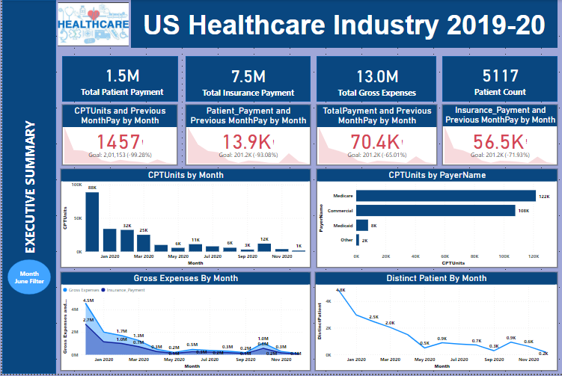

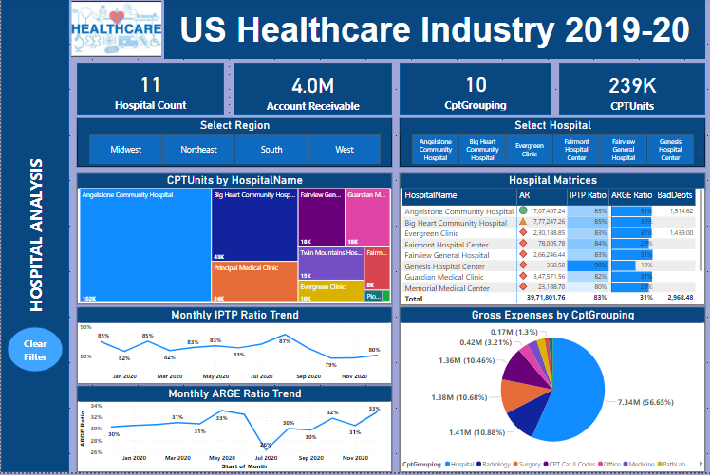

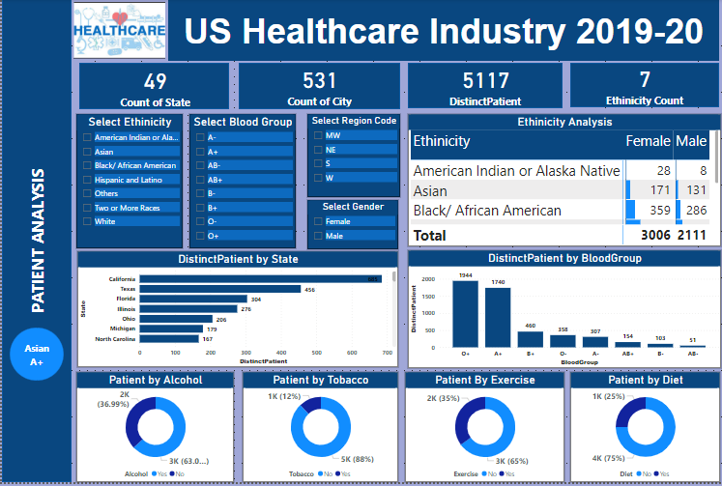

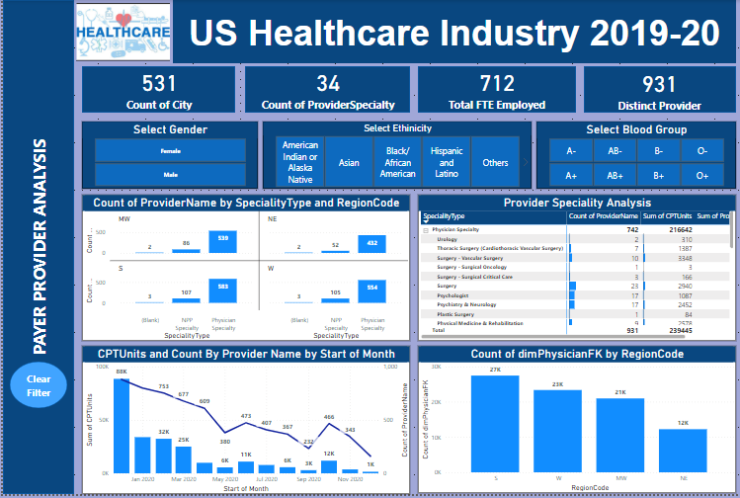

**CONCLUSION**

In this Power BI project, a thorough examination of the healthcare industry has been conducted, offering a multifaceted analysis encompassing patient demographics, hospital performance, and payer-provider dynamics. Through interactive visualizations and dynamic filters, stakeholders can delve into various aspects of the healthcare landscape, gaining insights into trends and patterns that shape decision-making. By presenting data effectively through charts, graphs, and tailored views, the dashboard facilitates understanding and facilitates strategic planning for healthcare organizations and policymakers.

One of the key highlights of this project is its ability to provide actionable insights derived from comprehensive data analysis. By evaluating regional impacts, assessing hospital performance, and analyzing trends over time, decision-makers can identify areas of concern, allocate resources efficiently, and develop targeted interventions to address challenges effectively. Furthermore, the examination of payer contributions and procedure dominance offers valuable insights into cost management strategies and resource optimization, essential for ensuring financial sustainability and quality patient care.

In conclusion, this Power BI project serves as a vital tool for stakeholders in the healthcare sector, offering invaluable insights into the complex dynamics of the industry. By leveraging advanced analytics and visualization techniques, the dashboard enables informed decision-making, strategic planning, and proactive management of challenges posed by the COVID-19 pandemic. Moving forward, the project's comprehensive analysis and actionable insights will continue to play a crucial role in driving positive outcomes, improving patient outcomes, and enhancing operational efficiency within the healthcare ecosystem.